**Block-Chain Powered Property Registry Solution**

**Introduction**

Digitalization and the evolution of new information technology (IT) is perhaps the strongest power of change in society. The technology called “blockchains” is one of the most talked about technologies in recent years, both within the IT community, and within the financial services industry. The technology includes making digital vouchers or verification records for digital files, for example documents or transactions. These verification records can be considered as fingerprints for the digital documents. These fingerprints are spared together in groups into a “block”. The block is then connected in a chain of blocks where the subsequent block also has a verification record, a unique mark (” fingerprint”) from the previous block. Therefore, it is not possible to add new data to older blocks (links) in the chain without altering the subsequent blocks. The chain’s ability to secure data and history is why it is called “The Trust Machine” by the Economist.

Outlining the technology and the applications conceivable with the blockchain technology is not simple. Partly because it is relatively hard and partly because the area is experiencing intensive development and new applications and new actors are rapidly becoming entrenched in the field. The contemporary IT architectures most often get security by making the system unreachable behind firewalls and with specific network connections. For example, there are just a couple of players, such as banks, real estate agents and several government institutions who can connect their systems to databases at the Registration office. Blockchain technology makes it conceivable to release verification records for registries, reports, and more outside of firewalls without endangering the security of the original documents.

There is a rule for right of access to public records in any country. Transparency and openness of public documents and decisions creates trust in government offices and in the welfare society. Anybody can request documents as indicated by the guideline of right of access. The blockchain permits many individuals sometimes anyone to check the verification records. Therefore, everybody can believe that the person who has the original document, and who can reproduce the verification records, is telling the truth.

**Purpose of the project**

Disputed land ownership is often a reason of conflict in the state of Andhra Pradesh in India. The present system, where land and property records are brought together in government databases, is inherently subject to improper or unauthorised manipulation. This can make it hard to reliably and unequivocally prove who owns a given property if records are suspicious, incongruent, or for some reason missing. The government of Andhra Pradesh is exploring technologies like blockchain that can help solve these problems by decentralising data storage in such a way that it becomes difficult to manipulate without both having the proper authority and following proper protocols.This has the potential to eliminate fraud and errors, and greatly reduce the administrative burden of land registration and title transfer.

**The Problem Statement**

1. Most Land and Property is not enlisted. The World Bank says that only 30% of land rights are registered or recorded around the world – and this needs to be changed. Most nations do not have a central property register.

2. Current Land and Property registers are open to abuse. These are held in databases or paper formats that are open to mishandle and abuse by corrupt officials. These officials often alter the records in return for favours or bribes.

3. The records are not safe from stealing or cataclysmic events like floods, flames and storms.

4. The Registers are fragmented and not all inclusive.

**The Concept of Block Chain in the Transfer of ownership**

Blockchain technology is intended to cut costs and to make the use of Trusted Third Parties, such as Governmental organisations, Banks and Notaries. It is intended to give individuals control on the procedures in the blockchain, without the use of a man-in-the-middle. In well-working Land Registry systems there are solid Trusted Third Parties associated in the transfer of ownership of immovable property. Because of the design of the process of transfer of ownership in these systems, the lawful certainty is ensured, and rightful claimants are secured. Apart from the registration of transactions, there is also a connection between the transaction and the reality, the actual circumstance. It is questionable whether Blockchain technology can playout these components as well or substitute a well functioning Land Registry, especially in situations where Land Registries are well-functioning and trusted by its clients. In countries where there are no such (reliable) registries, the practice of Blockchain technology perhaps appears more befitting.

The creation of a reliable and accessible and/or public administration containing a wide range of transactions using the capabilities of the network organisation (simply like the structure of the Internet, a network without a single point of failure). Blockchain technology offers a new perspective on how to keep a registration and to make information more accessible (in a registration). This methodology fits the self-reliance and it is intriguing to take into account when designing new registrations, despite the fact that there are very few Blockchain-based applications, particularly in Land Registration matters, and little is known about potential drawbacks of this Idea. In the Netherlands, Dutch Kadaster is doing some exploration on the use of Blockchain in cases of sharing explicit data sets, concerning open data. If the technique appears fit for this purpose, these data sets will be put on blockchain, so everyone utilizing these open data sets can see the dataset is put on the blockchain.

A technical solution should be implemented to circumstances where multiple parties can perform exchanges. There is a requirement for a decentralized solution that guarantees reliability and security of data. There are a few implementations of blockchain that may offer helpful functionalities. These applications possibly can provide chances to ease current IT systems, underpinning and supporting a Land Registry system. Perhaps it is conceivable to realize other functionality at lower costs and with reduced difficulty. At this moment Dutch Kadaster is working on a proof of concept for a blockchain-based method of signing and uploading notarial deeds to the Land Registry office. Bitcoin is the first and most known application of blockchain technology. It combines all three characteristics; it reduces the role of the traditional banks and it ensures that the reliability is organised into a network and it provides a technological solution.

When we started our research about block chain subject area, we came to know about the land property ownership problem being faced by Andhra Pradesh State. We felt delirious when we heard that the state is constructing a special building called Fin-Tech Valley especially for Block chain research and projects. So far, the block chain is all about bitcoins and online agreements, so we wanted to explore how block chain can be implemented in other areas like Property ownership, Banking, Crime detection, Voting…Etc.

Although the state is already working on the project with Chroma Way company, we tried to build a project based on this idea.

**Technologies Stack**

**Kotlin**

Kotlin is a programming language presented by JetBrains, the official planner of the most savvy Java IDE, named IntelliJ IDEA. This is an unequivocally statically composed language that sudden spikes in demand for JVM. In 2017, Google declared Kotlin is an official language for android improvement. Kotlin is an open source programming language that joins object-situated programming and useful highlights into a novel stage.

Kotlin is another open source programming language like Java, JavaScript, and so on. It is a significant level emphatically statically composed language that joins useful and specialized part in an equivalent spot. At present, Kotlin targets Java and JavaScript. It runs on JVM.

Kotlin is affected by other programming dialects, for example, Java, Scala, Groovy, Gosu, and so forth. The linguistic structure of Kotlin may not be like JAVA, in any case, inside Kotlin is dependent on the current Java Class library to deliver magnificent outcomes for the software engineers. Kotlin gives interoperability, code security, and lucidity to the designers around the globe.

*Advantages of Kotlin*:

Easy language: Kotlin is a useful language and extremely simple to learn. The sentence structure is basically like Java, consequently it is anything but difficult to recollect. Kotlin is progressively expressive, which makes your code increasingly coherent and justifiable.

Concise: Kotlin depends on JVM and it is a utilitarian language. Consequently, it decreases heaps of standard code utilized in other programming dialects.

***Runtime and Performance*** − Better performance and small runtime

***Interoperability***: Kotlin is sufficiently experienced to assemble an interoperable application in a less mind-boggling way.

***Brand New***: Kotlin is a new dialect that gives engineers a new beginning. It's anything but a substitution of Java, however it is created over JVM. It is acknowledged as the main authority language of android improvement. Kotlin can be characterized as - Kotlin = JAVA + some new features.

:

***Namespace declaration*** − Kotlin permits designers to announce the capacities at the top level. Nonetheless, at whatever point a similar capacity is proclaimed in numerous spots of your application, at that point it is difficult to comprehend which capacity is being called.

***No Static Declaration*** − Kotlin doesn't have normal static dealing with modifier like Java, which can make some issue the regular Java designer.

Kotlin is a programming language and has its own design to dispense memory and produce a quality yield to the end client. Following are the various situations where Kotlin compiler will work in an unexpected way, at whatever point it is focusing on various other sort of dialects, for example, Java and JavaScript.

Kotlin compiler makes a byte code and that byte code can run on the JVM, which is equivalent to the byte code produced by the Java .class document. At whatever point two-byte coded document runs on the JVM, they can speak with one another and this is the means by which an interoperable element is set up in Kotlin for Java.

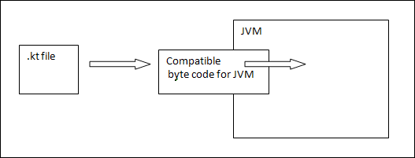

At whatever point Kotlin targets JavaScript, the Kotlin compiler changes over the. kt document into ES5.1 and creates a good code for JavaScript. Kotlin compiler is fit for making stage premise perfect codes by means of LLVM.

**Spring boot**

Spring Boot gives a very good stage to Java designers to build up an independent and creation grade spring application that you can simply run. You can begin with least arrangements without the requirement for a whole Spring design arrangement.

Advantages of spring boot

Advantages offered by spring boot to its developers are:

* Easy to comprehend and create spring applications
* Increases efficiency
* Reduces the development time

Spring Boot is planned with the accompanying objectives:

* To stay away from complex XML design in Spring
* To build up a creation prepared Spring application in a simpler manner
* To lessen the advancement time and run the application autonomously
* Offer a simpler method for beginning with the application

Why spring boot?

You can pick Spring Boot on account of the services and advantages it offers as given here

* It gives an adaptable method to arrange Java Beans, XML setups, and Database Transactions.
* It gives a ground-breaking batch preparing and oversees REST endpoints
* In Spring Boot, everything is auto arranged; no manual setups are required
* It offers comment/annotation-based spring application
* Eases dependency management
* It incorporates Embedded Servlet Container

**Angular 8**

angular 8 is a client-side TypeScript based system which is utilized to make dynamic web applications. It is fundamentally the same as its past renditions except for having some extensive features.

* Time-to-time (e.g. news update networks applications)
* Location-to-location (e.g. Climate projection web applications)
* User-to-user (e.g. Gmail, Facebook type applications)

Some of the most important features of Angular 8 are

* Angular 8 helps in TypeScript 3.4.
* Angular 8 helps web workers.
* The newly designed compiler using Angular 8 is Ivy Rendering Engine.
* Angular 8 helps in dynamic imports for all the lazy loaded modules.
* Angular 8 supports AOT compiler and Bazel incremental builds

**HTML 5**

HTML5 is the next major HTML standard revision that supersedes HTML 4.01, XHTML1.0 and XHTML1.1, HTML5 is now the standard for the world wide web for structuring and presenting content.

HTML5 is working with both the World Wide Web Consortium(W3C) and the Web Hypertext Application technology group (WHATWG).

This new standard introduces features like video playback and drag and drop that have been there before with dependent third-party browser plug-ins like Adobe Flash, Microsoft Silverlight and google Gears.

**New features for HTML5**

Some of the most important feature introduced in HTML5 are

New Semantic Elements- These can define with examples like <header>, <footer> and <section>.

* Forms 2.0- A lot of improvements to HTML web forms where many new attributes have been introduced for the <input> tag.
* Persistent Local Storage- To achieve goals without the use of third-party plugins.
* WebSocket – it is a new generation for two-way communication technology for web applications.
* Server Sent Events- It introduces events such that events flow from web server to the web browser which are known as Server- Sent events (SSE).
* Canvas- It helps 2-D drawing surface which we can program using JavaScript.
* Audio & Video- It helps in adding audio or video on the webpages with any help from third party plugins.
* Geolocation- All the users can select if they want to share their personal location with the web application.
* Microdata-It helps us create our own vocabularies beyond HTML5 which leads in extension of our web pages with self custom semantics.
* Drag and drop- helps in selecting an item and placing it anywhere on the screen using the drag and drop feature.

**Bootstrap**:

Bootstrap is a smart, intuitive and efficient mobile first front -end platform for faster and easier web creation. It uses HTML, CSS and JavaScript.

Why use Bootstrap?

Mobile first approach- bootstrap 3 framework includes many mobile first style within the whole library instead of in separate files.

Browser Support- It is supported by all the elite browsers.

Easy to get started-With the help of basic knowledge of languages like HTML and CSS anyone can start with bootstrap. Also Bootstrap provides us with a very good documentation.

Responsive design – It a very responsive CSS which will adjust to Desktops, tablets and mobiles.

It provides us with a very clean and stable solution for building an interface for developers.

It has many built-in features which are very easy to customize.

It also provides customizable web and the best feature is that its open source.

**Proven DB**

ProvenDB is a MongoDB compliant database service that blends conventional database functionality with Blockchain features such as immutability. Using ProvenDB, you can write applications that connect data to the public blockchain and provide cryptographic proof of data integrity and history.

**Drawbacks of the Blockchain**

However, public blockchains-like Ethereum and bitcoin-even these are only capable of a handful of transactions per second. The cost of storing any non- specific amount of handful of transactions per second. The cost of story any nonspecific amount of data on such blockchain is utterly prohibitive. Although there are alternate Blockchains that have higher throughput and lower latencies, these blockchains do not have the cryptographic power of large public blockchains, such as those underlying Ethereum or bitcoin.

**Bridging the gap with ProvenDB**

ProvenDB layers at the top of a standard database engine adding main blockchain features to our database. The result is a fully functional database with all its services.

* It is Mongo DB compatible.
* It provides with normal throughput and latency in our work.
* It uses rich query and data operation.
* It has very strong privacy.

It also provides features which are listed below:

***Immutability***- By default all versions old or updated are stored and saved. Old version of the data item can be thrown in the back, but the same version of the data is never destroyed.

***Tamper detection***- Some versions of database are hashed in blockchain and the same version can always be proven to be created at a very particular time and we can prove that it has not been altered.

***Point -in-time history***- Any data in the database at any point of time can be retrieved without much difficulty.

***Data Provenance***- It shows the entire history of operations taken place on the data with showing the initial contents, changes made to it at each point at time.

Some reasons to use ProvenDB:

* Prove that data has not been altered.
* Prove that date of a legal or official document.
* To show how the data has not been altered.
* To show the exact history of a data.

Some example where it is very helpful are

* Document Management Systems.
* Intellectual Property and Media management solutions.
* Accounting Systems.
* Legal Record Keeping
* Government and regulatory Applications
* Audit and Access Management Systems.

**Node JS**

Node.js is an open source, cross-platform runtime environment for developing server-side and networking applications. Node.js applications are written in JavaScript and can be run within the Node.js runtime on OS X, Microsoft Windows, and Linux.

Node.js also provides a rich library of various JavaScript modules which simplifies the development of web applications using Node.js to a great extent.

Where to use Node Js?

Following are the areas where Node.js is proving itself as a perfect technology partner.

* I/O bound Applications
* Data Streaming Applications
* Data Intensive Real-time Applications (DIRT)
* JSON APIs based Applications
* Single Page Applications

**Tomcat Server**

Tomcat is an application server designed to execute Java servlets and render web pages that use Java Server page coding. Accessible as either a binary or a source code version, Tomcat's been used to power a wide range of applications and websites across the Internet.

**SendGrid API**

This API allows us to send email to the respected users. SendGrid provides libraries which help us to integrate it with 7 languages: C#, Go, Java, NodeJS, PHP, Python and Ruby.

Advantages

* Real time.
* It provides global support.
* Scalable

Disadvantages

* Size of the email should be less than 30 mb.
* Total number of recipients must be less than 1000.
* The total length of any custom arguments must be less than 10000 bytes.

**System Requirements of the project**

* Windows 10
* Ram 4Gb
* Processor i3 1.60ghz
* System type 64-bit OS

**Architecture**

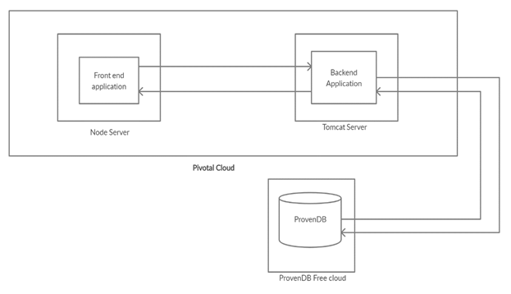

Fig: Architecture of our system

So Blockchain powered property solution architecture shows us where the technologies are used in our project where front end technologies like Kotlin, Spring Boot and ProvenDB are our Backend technologies which run on Tomcat server. The Backend application are responsible for storing the data where data can be described as user data, admin data, registration officer data and all the advertisements. So, in general the backend in responsible for handling the data.

The Backend Applications are connected to ProvenDB database which is MongoDB complaint database but uses blockchain technology so our aim purpose of using blockchain is fulfilled by it. Feature provided by ProvenDB helps in making the data immutable and it provides many great features which are unique to it.

The frontend applications which we use are Angular 8, HTML5, Bootstrap and Node JS. These are responsible user interface which will user for details like name, e-mail id, phone number while creating a user profile. All this information is asked in front end and which is then transferred to the back end which uses ProvenDB to store all the information.

As Front end and Back end both run on different servers as the Frontend application runs on the Node JS server and the Backend application runs on the tomcat server and both these applications interact with each other and share information among themselves. Both servers are hosted in the pivotal cloud.

Implementation

The project implementation is divided into three modules.

1.Users

2.Registration

3.Advertisements

1. Users: People who can use this application are categorized into 3 types.

a. Admin

He is responsible for creating login credentials for registration officers

He is not allowed to do any registrations.

He can only see the block chain data but not able to add any new blocks to the block chain.

He can also add his own advertisement as a normal user.

b. Registration Officer

He transfers the property ownership from seller to buyer.

He will authenticate their physical documents at the time of registration.

He is the only user who can add a block to the chain.

He is not responsible for deciding the value of the property.

He cannot alter the block chain because he is only allowed to open registration module when both buyer and seller advertised their properties from their public user accounts.

c. Public User

A person who wants to buy or sell a property is a Public User. He needs to sign up for the application.

If a user wants to sell his property, he can give an advertisement in the application in the Add advertisement tab.

If a user wants to buy a property, he can check the advertisement tab for available properties and to proceed further he has to contact the seller himself.

A seller can only add/delete advertisement only when the property is validated by the registration officer.

2. Registration

Registration process has following sequence of steps.

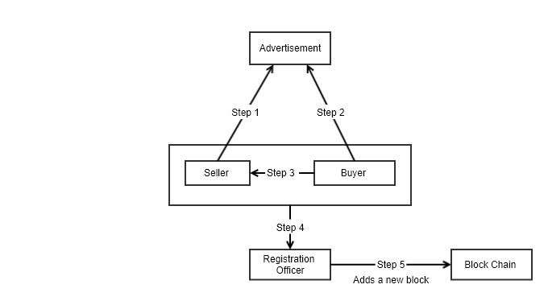

Fig: Registration Process

Step 1: A seller can advertise his property details in this application, or he can give the advertisement in another platforms.

Step 2: A buyer can see the endorsement either in Block-Chain powered registry solution application or in another platforms.

Step 3: Buyer contacts the seller to enquire about the property and to negotiate the price of the property.

Step 4: Both buyer and seller visits registration officer to finish registration formalities. The registration officer verifies the land documents and completes the legal notary process. He transfers the property to buyer from seller in property registry solution application.

Step 5: A new block will be added to chain in the database.

3. Advertisements:

There are two tabs for advertisements.

Add advertisements and advertisement tab.

Only a seller can add/delete advertisements in Add Advertisement tab.

Advertisement tab is an active list of all available properties for selling.

Once a property is registered concerning advertisement from the advertisements tab will be removed automatically by the application.

**User Interface Screens**

Home Screen of the Blockchain-Powered Property Registry Solution

Any user (Admin, Registration officer, Public User) needs to Login into the page

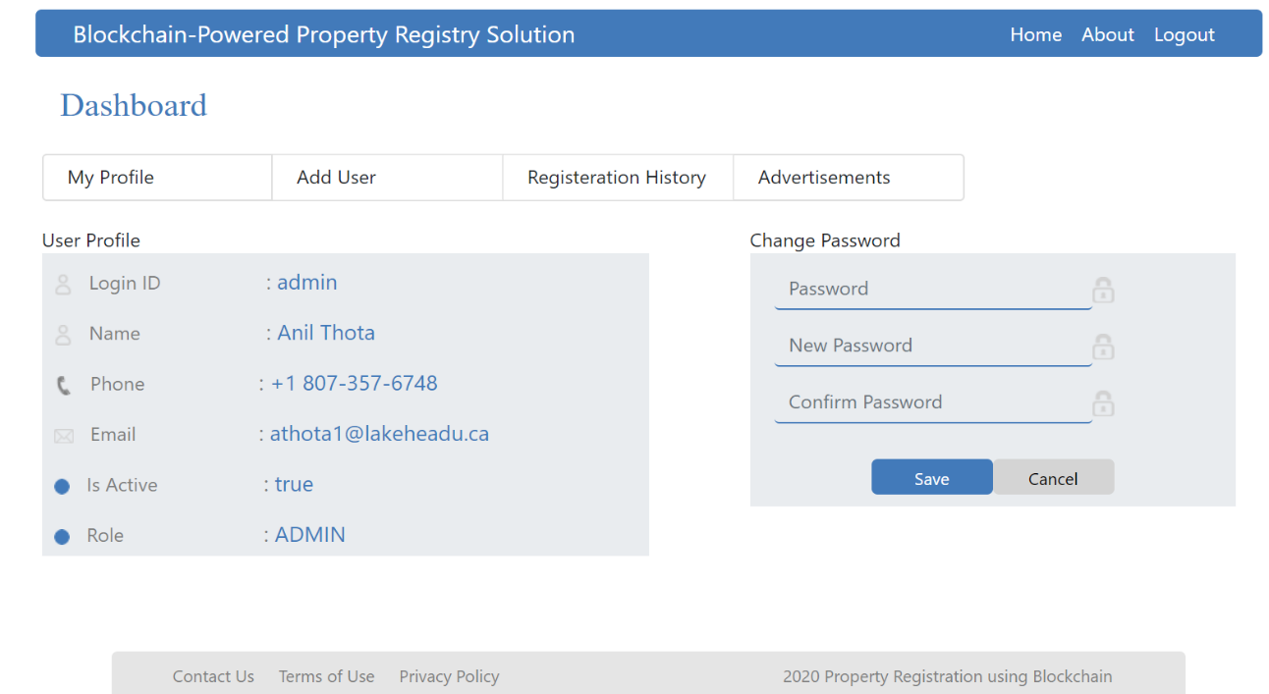

Fig: Dashboard of the Admin

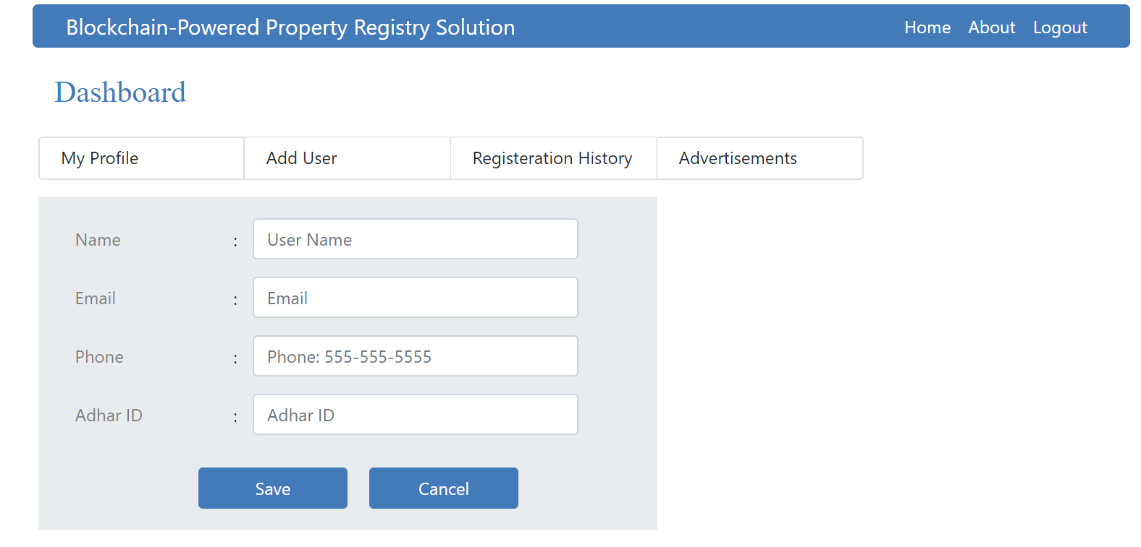

Fig: Admin Add User page for adding new registration officer.

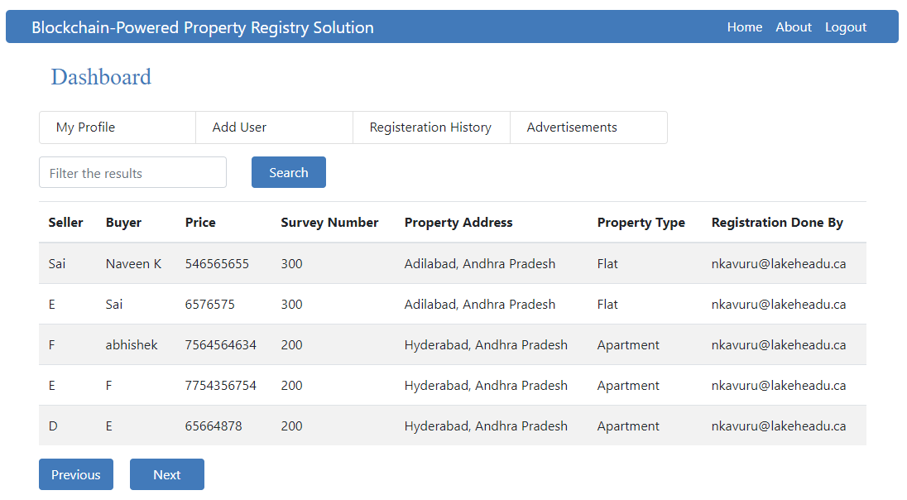

Fig: Registration history (Any User can see the registration history tab)

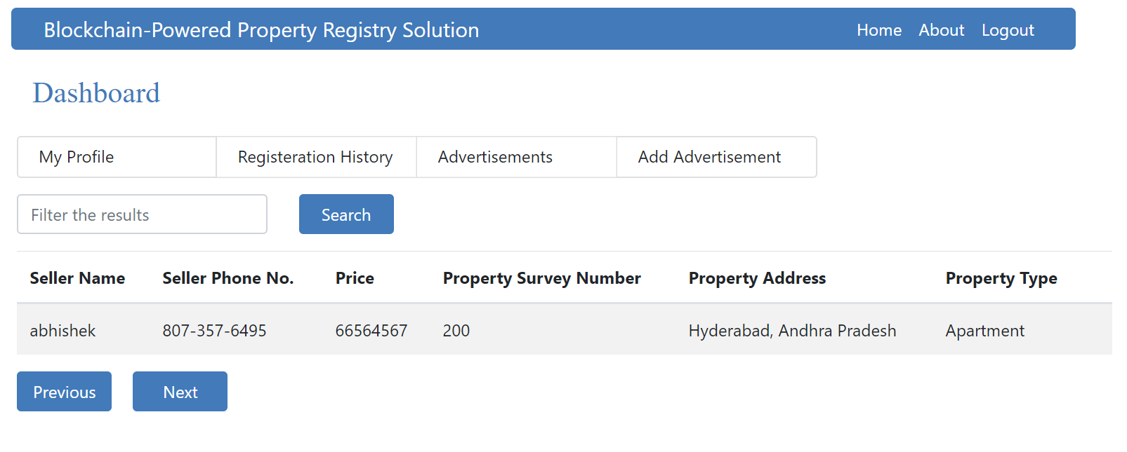

Fig: Advertisements History Tab

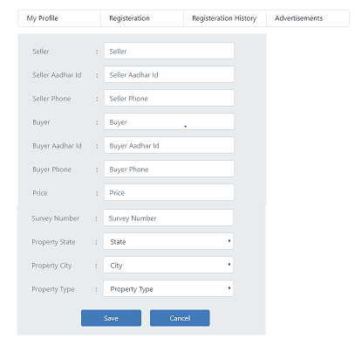

Fig: Registration Tab

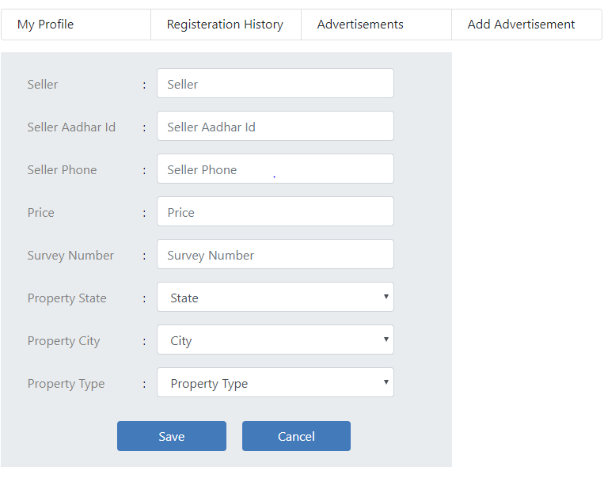

Fig: Add Advertisement Tab

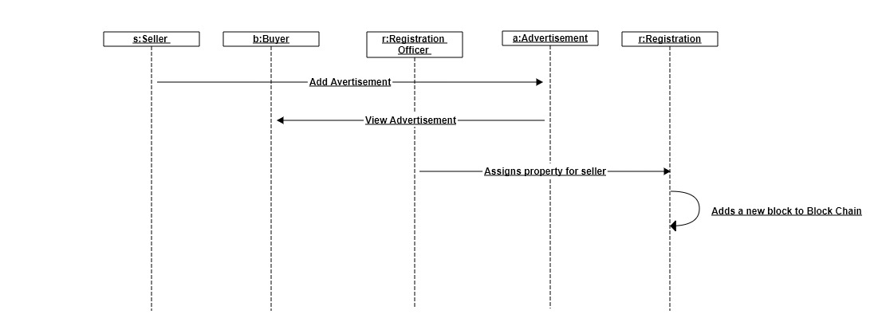 **UML Diagrams**

Fig: Sequence Diagram

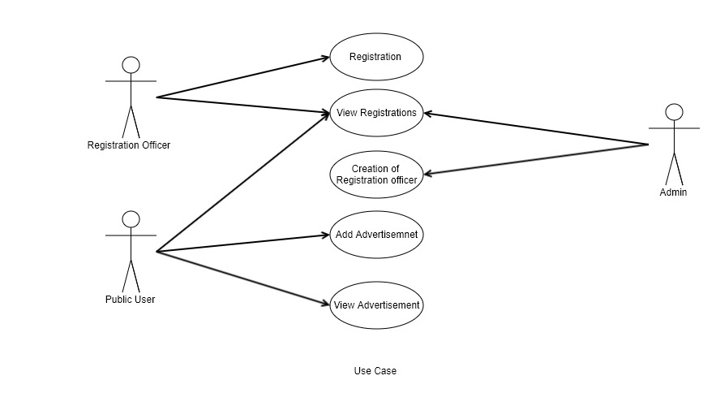

Fig: Use Case Diagram

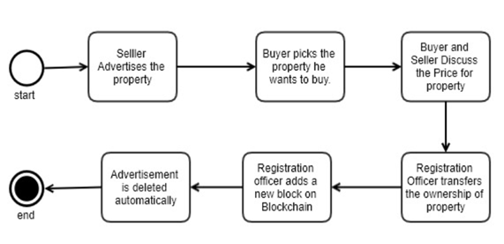

Fig: Workflow Diagram

**Installation Steps**

To run this application locally, follow the following steps

1. Install the JDK 1.8.
2. Install the Node server (version 12.14.1).
3. Install the Maven (version 3.6.3)
4. Clone the source code from GitHub

<https://github.com/thotaanil19/blockchain-application.git>

1. Build the frontend code by running following command from command prompt from frontend project root folder

**npm build**

1. If waring in command prompt, run the

**npm audit fix**

1. Run the frontend code with following command

**ng serve**

1. Build backend code by running following command from backend root folder

**mvn clean install package**

1. Run the backend code

**mvn spring-boot:run**

**Conclusion**

A Land Registry system cannot be changed from a deed to a title by introducing a blockchain-based Land Register. It will not bring any changes in any system. What goes in, will come out. In case blockchain will be used in a deeds system, there will still not be issued any title by the Registrar. In case of a title system the title will be transferred by using blockchain; the title will not get lost. Blockchain technology will not improve legal certainty with regard to the content and legal meaning of the first block. In a case where there is uncertainty with regard to the title holder, blockchain will not bring any changes. Improvement of the quality and the completeness of the Land Registers can be realised by recording new transactions and/or – depending on the legal system – titles in the subsequent blocks or by uploading new transactions in the first block. This is like a ‘classic Land Registry system’: by recording new deeds or transactions, the Land Registers become more accurate and give an actual overview of the current state of play.

**Future Work**

1. Currently the application was developed using the Email API. We are planning to implement SMS API as it is more secured way of verification.

2. We are planning to do User Interfaces.

3. The Application was not designed to store concern land documents. Tabs for uploading property files should me implemented.

4. We are planning to add Registration officer digital signature.

5. We are also planning to remove the registration officer involvement during the registration process.

6. Planning to do a separate chat platform for buyer and seller communication in the advertisement tab itself.

**References**

1. Business Insider UK, GOLDMAN SACHS: ’The Blockchain can change... well everything’ (http://uk.businessinsider.com/goldman-sachs-the-blockchain-can-changewell-everything-2015-12), publication 2 December 2015, access 29 April 2016

2. http://www3.weforum.org/docs/WEF_GAC15_Technological_Tipping_Points_ report_2015.pdf

3. <http://www.economist.com/news/leaders/21677198-technology-behind-bitcoincould-transform-how-economy-works-trust-machine>

4. A slightly more complete description is that a blockchain can be described as a ledger of unique events, signed and ordered in time.

5. Different encryption algorithms generate different digital fingerprints for the same document. If the same encryption algorithm, e.g. SHA256 is used, the fingerprint will be the same.

6. http://www.forbes.com/sites/laurashin/2016/04/21/republic-of-georgia-to-pilot-landtitling-on-blockchain-with-economist-hernando-de-soto-bitfury/#23e412086550

7. Business Insider UK, GOLDMAN SACHS: ’The Blockchain can change... well everything’ (http://uk.businessinsider.com/goldman-sachs-the-blockchain-can-change-welleverything-2015-12), publication 2 December 2015, access 29 April 2016

8. http://www3.weforum.org/docs/WEF_GAC15_Technological_Tipping_Points_ report_2015.pdf

9. <http://www.economist.com/news/leaders/21677198-technology-behind-bitcoincould-transform-how-economy-works-trust-machine>

10. This is a simplification of how it works. In reality each participant adds a number and run SHA256 on the block with the number. If the result is a hash with a sufficiently low number, the computer has proved it has spent energy on guessing and is rewarded with Bitcoins and the transaction fees coming from the verifications that wants to be added to the blockchain. This is known as Proof of Work.

11. <http://www.forbes.com/sites/rogeraitken/2016/04/05/bitlands-african-blockchaininitiative-putting-land-on-the-ledger/#434717c81029>

12. Distributed Ledger Technology: beyond block chain. A report by the UK Government Chief Scientific Adviser, December 2015

13. http://www.di.se/artiklar/2016/5/3/anders-borg-bankerna-ar-pa-vag-mot-ett-uberlage/